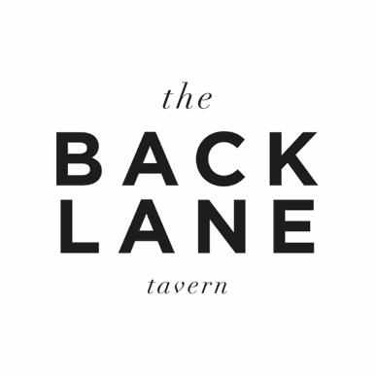

V E G A N

Spelt sourdough, arbequina olive oil (gf*) 7.0

Smoked aubergine, nut dukkah, pickled chilli, flat bread 8.0

Wild mushroom, spring onion on toast (gf*) 8.0

Vietnamese rolls, peanut sauce, crispy shallot (gf) 9.5

Green beans, toasted almonds (gf) 7.0

Heritage beetroot, chard, hazelnuts, confit garlic 7.0

-A discretionary 12.5% service charge will be added to every bill-

gf (gluten free) gf* (gluten free available)

E: info@backlanetavern.co.uk T:01993 810 826

V E G A N

Spelt sourdough, arbequina olive oil (gf*) 7.0

Smoked aubergine, nut dukkah, pickled chilli, flat bread 8.0

Wild mushroom, spring onion on toast (gf*) 8.0

Vietnamese rolls, peanut sauce, crispy shallot (gf) 9.5

Green beans, toasted almonds (gf) 7.0

Heritage beetroot, chard, hazelnuts, confit garlic 7.0

-A discretionary 12.5% service charge will be added to every bill-

gf (gluten free) gf* (gluten free available)

E: info@backlanetavern.co.uk T:01993 810 826

